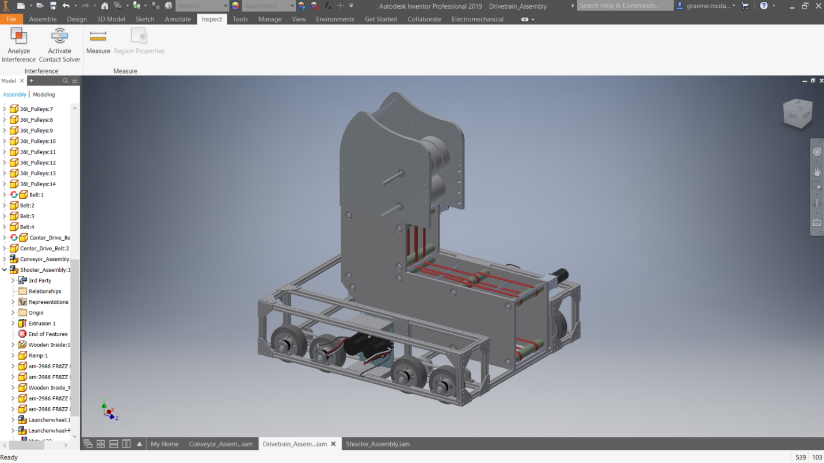
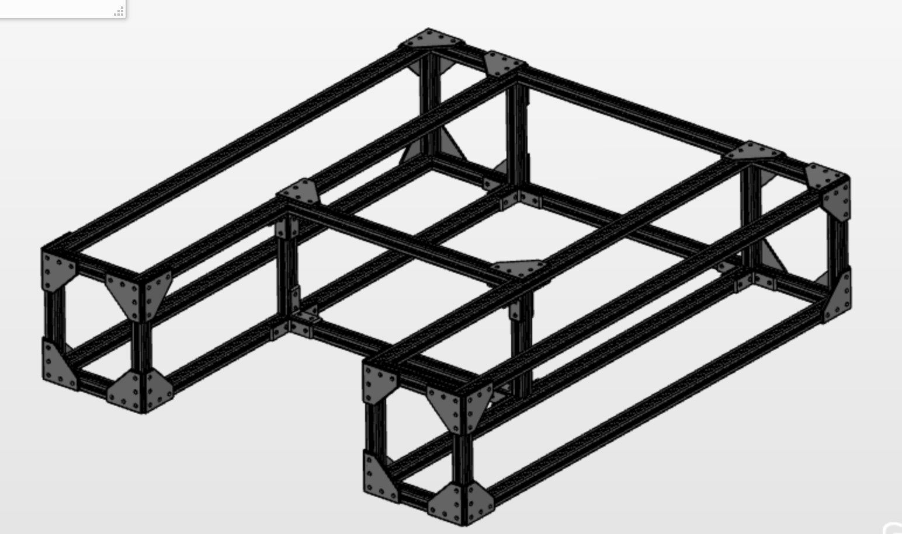
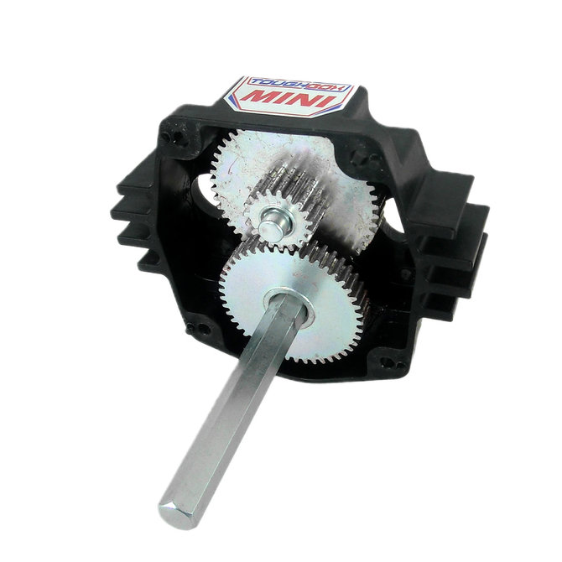
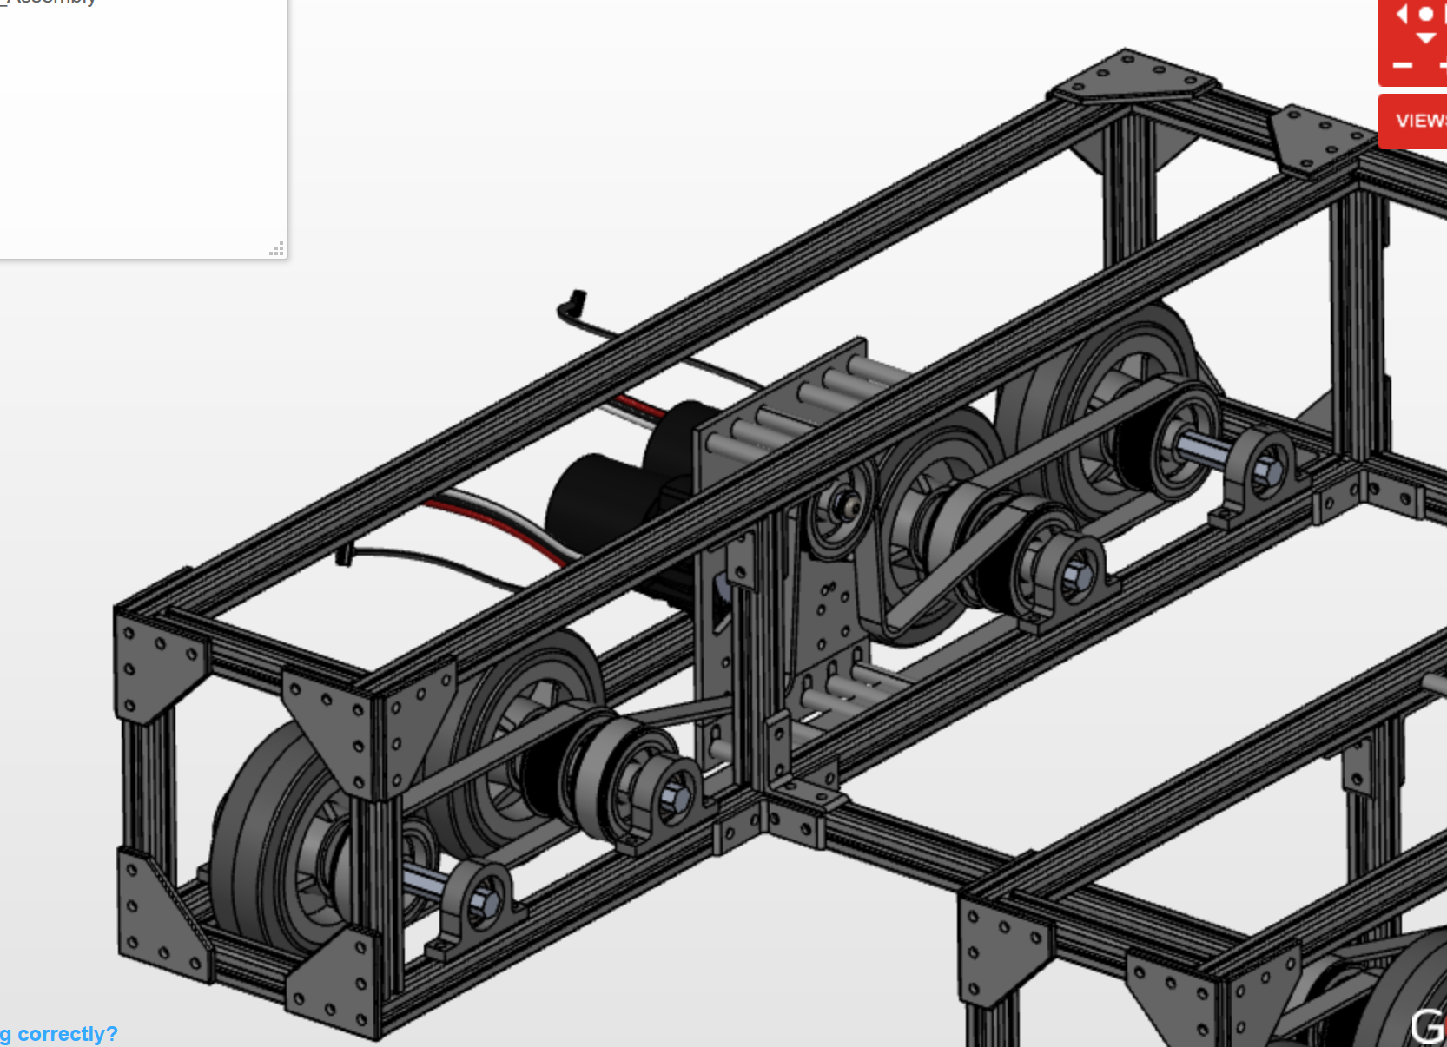
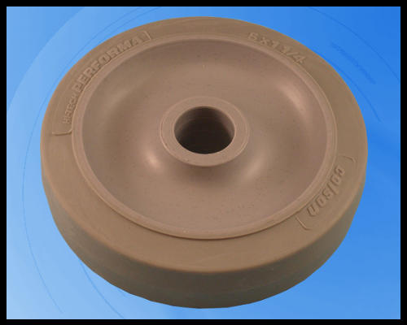
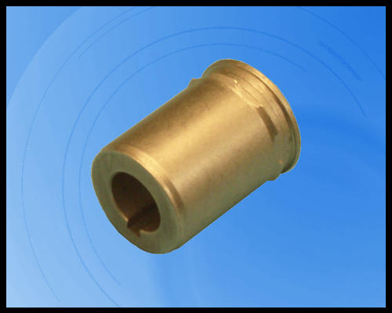
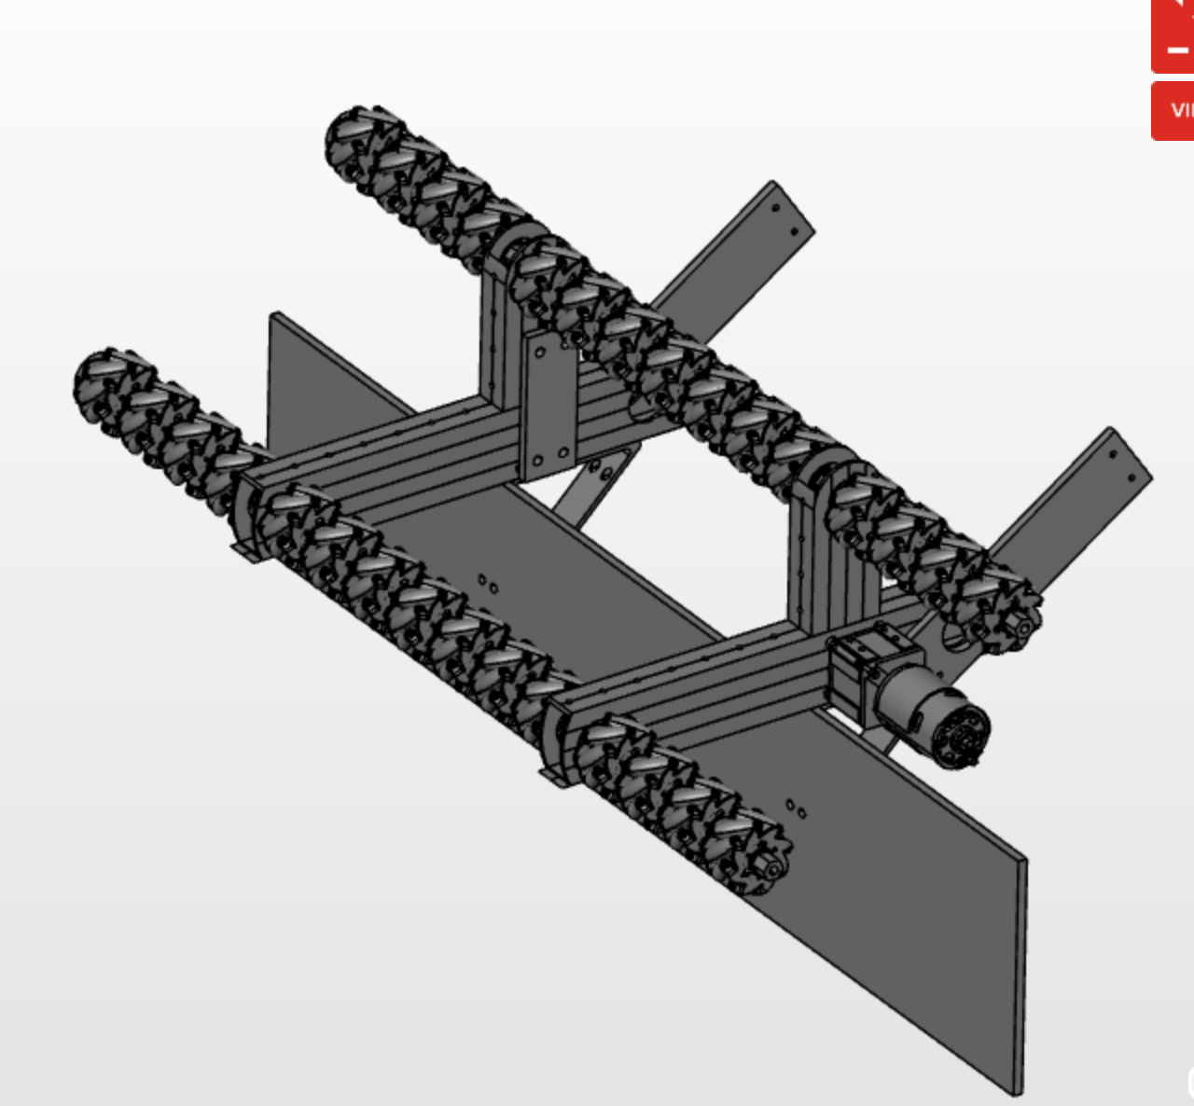
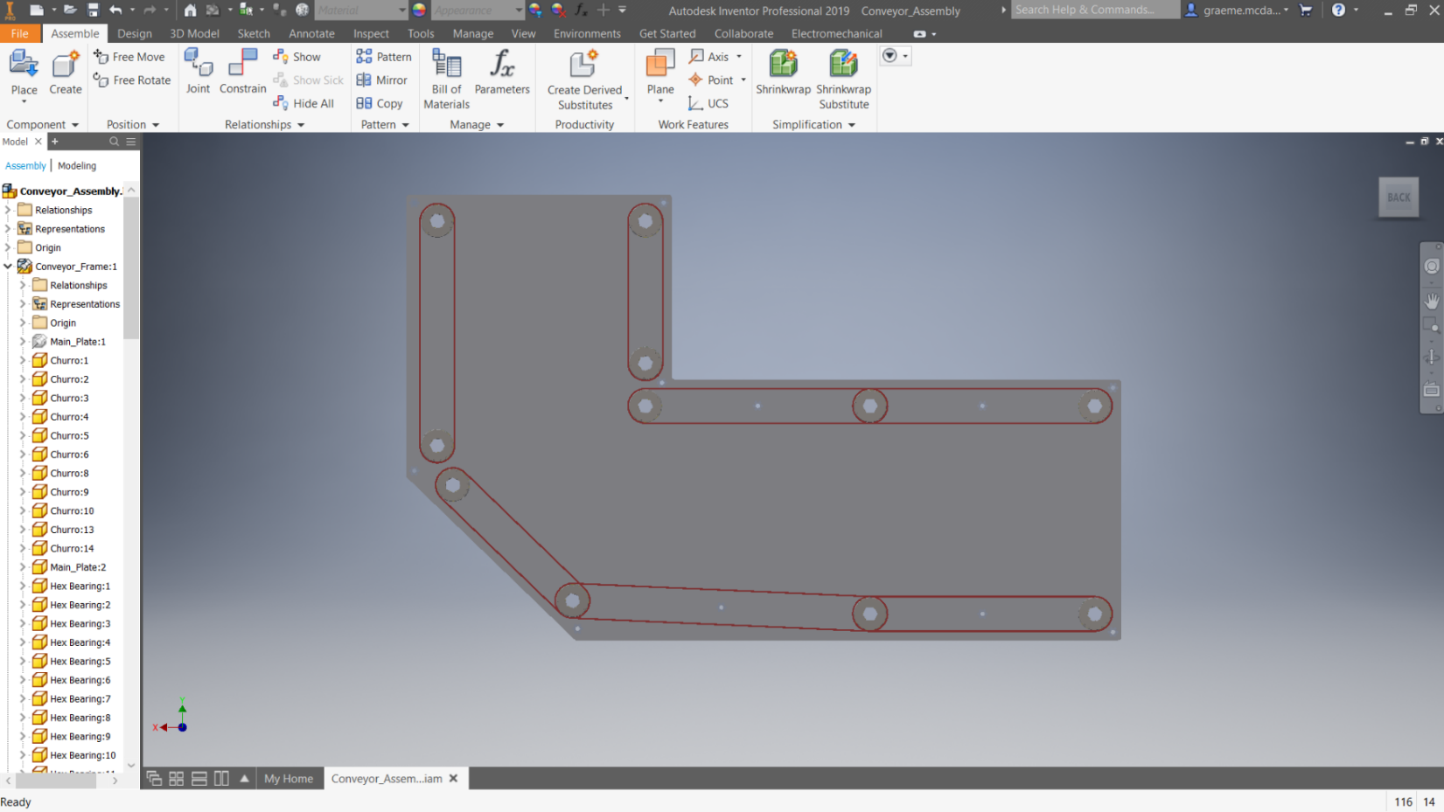
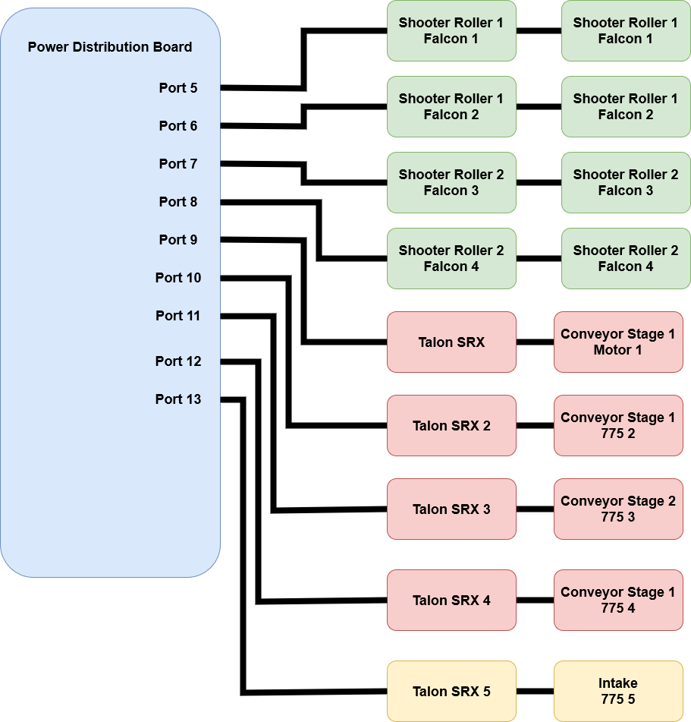

Fortitude Robotics

Infinite Recharge

Robot Technical Manual

2/1/2020
Colton Weed (Team Captain)
Graeme McDaniel (comic relief)
Adam Tollios
Cian Mattern (fancy videos with annoying soundtracks)
Hannah Thiel (Smurf)
Scott Mueller (Stupid Lard)

Contents
1.Overview 5
2.Strategy 6
2.1.Scoring Potential Evaluation 6
2.2.Gameplay 6
1.Autonomous 6
2.Teleop 6
3.Endgame 6
3.Subsystems 7
3.1.Drivetrain 7
4.Mechanical 7
5.Bill of Materials 10
6.Electrical 10
7.Programming 10
3.2.Fuel Cell Manipulator 11
8.Intake 11
9.Conveyor 11
10.Shooter 13
11.Bill of Materials 13
12.Electrical 14
Programming 15
3.3.Elevator Mechanism 16
13.Mechanical 16
14.Electrical 16
15.Programming 16
3.4.Electrical 17
16.Mechanical 17
17.Electrical 17
18.Programming 17
4.Cost Accounting Worksheet 18

Fortitude Robotics <Infinite Recharge>
<Graeme McDaniel>
Colton Weed
Updated: <most recent date edited>

Date | Author | Changes
1/26/2020 | Graeme | Initial Commit
2/1/2020 | Stupid Lard | Reformatting, adding conveyor info, pictures
Figure 1: table of edits

Overview
Figure 2: Robot Overview (missing elevator and intake)

Strategy

Scoring Potential Evaluation
<add details from kickoff about different ways to score points>
Priorities
Capture Fuel cells and shoot through the outer power port.
Climb and balance the Generator Switch

Gameplay

Autonomous
The robot starts with 3 balls in the conveyor. It will used a timed driving routine to drive through the middle of the field. Then it will use the Limelight to align with the outer power port and shoot fuel cells.

Teleop
The robot will collect 5 fuel cells at a time and score them in the outer power port shooting from the initiation line

Endgame
The robot will climb the generator switch and adjust its position on the bar to level the switch. This is done teleop control.

Subsystems

Drivetrain
The drivetrain uses a space frame design that has worked well for us in the past but using lighter 20mm metric 80/20 t slot framing rather than 1”. Its assembled with gusset plates to make up for the weaker 5mm fasteners of the metric extrusion. These have the benefit of not requiring any machining to install and they also look cool. Eight wheel drive is used to prevent getting high centered on field obstacles and to allow the gearboxes to be fit between the wheels. This leaves the middle of the robot open for adding mechanisms so the drivetrain can be built before the other mechanisms.

Mechanical

Frame
Figure 3: Drivetrain Frame

Gearbox
Toughbox minis are modified with custom mounting plates. These plates replace the stock ones and allow easy attachment to the 80/20 frame. These gearboxes have very limited gear ratios compared to ones from VEX and WCP but they’re compact and easier to integrate with our frame. Additional gear reduction can be accomplished with the belt drive if necessary. They also required heavy and awkward spacer blocks to attach to the frame and a custom gearbox would provide even better integration but we prefer to keep it simple since the driving performance gain is marginal.
Figure 4: Toughbox Mini

Belt Drive
HTD-5mm x 15mm pitch belts transmit power. The central belt takes power off the gearbox and drives the two center wheels. Idler pulleys allow ensure adequate belt wrap on each pulley. Additional belts transfer power from those wheels to the outer ones. 15mm width belts and 36T pulleys keep belt loads low to ensure reliability over a build season since replacing belts is time consuming.
Figure 5: Drivetrain Belt Drive Configuration

Bearing Blocks

Axle Shafts

Wheels
5” Colson wheels provide enough ground clearance to drive over the field obstacles, good traction and won’t need to be replaced during a season. Custom hubs had to be broached for a ½” hex shaft but this was a reasonable compromise compared for the durability of the wheels, weight and our familiarity with them.

Figure 6: 5" Colson Wheel and Hub

Bill of Materials

Electrical

Programming

Fuel Cell Manipulator
The fuel cell manipulator consists of three sections, the intake, conveyor and shooter. The intake picks up the ball from the field and centers it on the middle of the robot to feed into the conveyor. The conveyor

Intake
The intake is stored upright at the beginning of the match to fit within the allowable robot size and flips down pneumatically. 2” Thriftybot mecanum wheels capture a fuel cell and center it so that it can be brought into the conveyor system. A single axle of wheels was found to allow the robot to run over the fuel cell before it could be moved to the center and into the conveyor. The improved intake uses a frame and two rollers to capture the fuel cell to keep it from shifting under the robot. It then has more time to be shifted to the conveyor system.

Figure 7: Intake Overview

Conveyor
The conveyor uses urethane belts to move balls from the intake to the shooter. It has two independent stages which move balls in and the second stage feeds balls to the shooter.

Shooter
The shooter is of a “hooded” design that accelerates the ball between one spinning roller and a curved sheet metal hood. A second roller accelerates the ball from the conveyor to the shooter to provide faster and more consistent shooting speeds. Each roller is driven by two Falcon motors with 1:1 belt drives.

Frame
3/8” Baltic birch plywood and ½” hex churro standoffs
<add picture here>

Hood
0.070” aluminum set in a groove
<add picture here>

Upper Roller
5”x 1.5” Colson Wheels driven by HTD-5 9mm belt, 1:1 ratio with 36T pulleys and 2x Falcon motors
<add picture here>

Lower Roller
4” Andymark Compliant wheels (black) driven by HTD-5 9mm belt, 1:1 ratio with 36T pulleys and 2x Falcon motors
<add picture here>

Bill of Materials

Electrical

Programming

Controller Layout
Left Joystick – mapped for driving the robot using tank drive,is currently scaled to limit max speed.

Left bumper & trigger – these two use the same command and are mapped to sucking in balls
they turn on the one smaller front conveyer and the intake and can be reversed and stoped.
The left bumper is for forward and trigger is for reverse, pushing either of them a second time
will stop the motors.

A Button – is used for limelight alignment to target, in its final state it will be a hold down button used to quickly get the robot in position. I would like it to ideally take less than 5 seconds.

B Button – is used to spin up the shooter it currently takes 5 seconds to reach max speed and is set to a max power of 80%, pushing the button agin will stop it.

X Button – will be used to engage all the conveyers and move balls up to a running shooter.
Y Button – will be used to pull the cylinder back from holding the balls in the conveyer away away from the shooter.

Elevator Mechanism

Mechanical

Electrical

Programming

Electrical

Mechanical

Electrical

Programming

Cost Accounting Worksheet

<add giant bill of materials spreadsheet here>

